Rayat Shikshan Sanstha’s
Balwant College, Vita
Department of Zoology
Academic Calendar 2023-24

Sr. No. | Departmental Activity | Date
1 | Commencement of Ist Term | 3 July 2023
2 | B.Sc.I, II, III Admission | First week of July
3 | Departmental Meeting- Annual Plan, Discussion and Distribution of syllabus and Departmental Files  Commencement of B.Sc. I Theory Lecture | Second week of July
4 | Departmental Meeting: M.Sc. I and II admission  Preparation of Documents and Presentation for NAAC  Submission of list of required Equipment’s and books | Third Week of July
5 | Departmental Wall Magazine- Animal of the week | Fourth week of July
6 | Commencement of B.Sc.I and B.Sc.II Practical  B.Sc.III | Fourth week of July
7 | Final Admission and Commencement of B.Sc.II Lectures and Practicals | Fourth week of July
 | Departmental Meeting regarding planning of Extra- curricular and Co- Curricular Activities. | First week of August
8 | Diagnostic test for B.Sc. I to distinguish slow and advance learners. | Second week of August
9 | Commencement of M.Sc. I and M.Sc. II Lectures and Practicals. | Second week of August
10 | Home Assignment | Second week of August
11 | Independence Day | 15th August 2023
12 | Guest Lecture on Snake Awareness | Fourth Week of August
13 | Organization of Teacher’s day | 5th September 2023
14 | Organization of students Seminars B.Sc. III, M.sc.I and M.Sc.II Student. | Second Week of September
15 | Internal Examination (B.Sc.I, II III & M.Sc.I , II) | Third Week of September
16 | Karmveer Bhaurao Patil Jayanti Celebration -  Organization Quiz Competition, Rangoli Competition, Elocution Competition, Expert talk on Karmveer Bhaurao Patil. | 22nd September 2023
17 | Organization of Wild Life Week (1st - to 7th Oct. 2023) | First week of October
18 | National Bird day, Bird count Activity | (5th -12th Nov) 2023
19 | Distribution of Projects to B.Sc.III and M.Sc.II Students | First Week of November
20 | National Cancer Awareness day | 7th November 2023
21 | Organization of Unit Tests (B.Sc. and M.Sc.)  Industrial Visit (Short tour) | Second week of November
22 | Term End Meeting | 11th November 2023
23 | Commencement of IInd Term | 24th November 2023
24 | Organization of NET/SET Coaching (M.Sc.I and II)  Departmental Meeting | Fourth Week of November
26 | Organization of Program under MOU Activity | Fourth week of November
27 | Discussion on short term course, Vermitechnology (B.Sc. III) and Apiculture  Update Departmental Website | First week of December
28 | Pre-semester of UG and PG classes | Second Week of December
29 | Organization of Health check-up camp on the occasion of birthday of Hon. Shradchandraji Pawar (President, Rayat Shikshan Sanstha’s Satara. | 12 December 2023
30 | Planning of study Tour for B.Sc.I, II, III and M.Sc.I & II | Second Week of December
31 | Organization of CIE (B.Sc.III, M.Sc.I and II | Second week of December
32 | Organization of Unit Tests (B.Sc. And M.Sc.) | Third week of December
33 | Organization of One Day Workshop on Applied Zoology (Goat Farming, Apiculture, Vermicomposting, Poultry and Sericulture) | Second Week of January
34 | Organization of Parent Meet | Second Week of January
35 | Organization of Alumni Meet | Second Week of January
36 | Organization of Extension activity Physical Check-up camp (Hb, BMI, BP and Blood Group) | Third week of January
37 | Departmental meeting: Discussion on syllabus Completion  Lead College Activity Organization of one day Workshop. | Third week of January
38 | Internal Examination of UG and PG classes | Fourth Week of January
39 | Celebration of Science Day | Third Week of February
40 | Organization of Student Seminars (M.Sc.I) | First Week of March
41 | Organization of Physical Check-up Camp for Ladies Faculty on Occasion of Woman’s Day | Second Week of March
42 | Organization of Guest Lecture M.Sc. Entrance Coaching | Third Week of March
43 | Organization of Theory and Practical Examination on Short Term Course | Fourth week of March
44 | Departmental Meeting: Practical Completion, Journal Completion and Certification of Journal and Departmental file completion for NAAC | First week of April
45 | Examination Duty for Practical Examination | Second week of April
46 | Commencement of University Examination | Third week of April
47 | World Bee day | 20th May 2024
48 | Practical Examination of B.Sc.I and II.  Completion of ISO/ AAA/ NAAC Documentation | Fourth week of April
 | Departmental Meeting- Completion of short term course | Third week of May
50 | Practical Examinations of M.Sc. I and II  Website Updation | Fourth week of May
51 | Term End Meeting | Second week of June

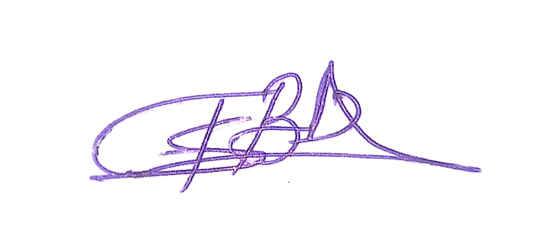

Head

Department of Zoology

